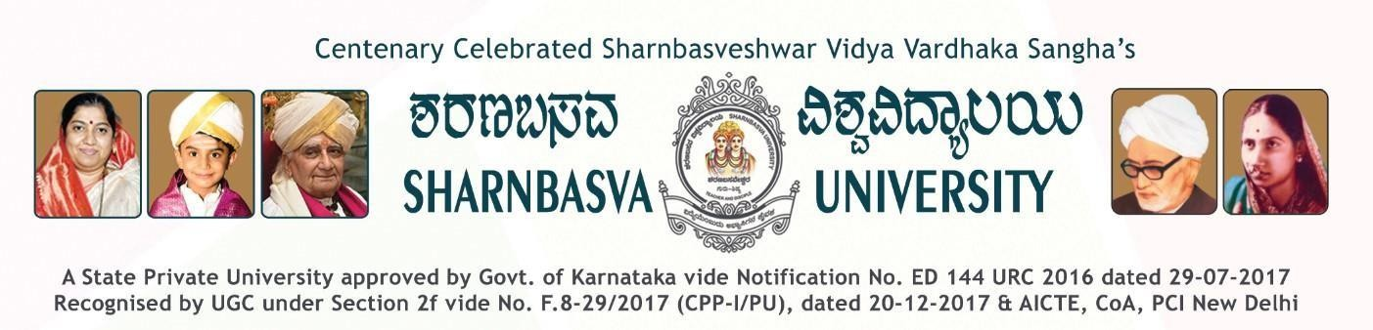

**A PROJECT REPORT**

**ON**

#### “Image Sharpening Using Knowledge Distillation”





Submitted by

**CHETAN GAROOR (SG22AID014) ARUNKUMAR.U.K (SG22AID008) SANKET.S.G (SG22AID040) REVANSIDAPPA T (SG22AID037)**

Under the Guidance of:

**Dr. Gajendran Malshetty**

**DEPARTMENT OF**

**ARTIFICIAL INTELLIGENCE AND DATA SCIENCE FACULTY OF ENGINEERING AND TECHNOLOGY [CO-ED] SHARNBASVA UNIVERSITY KALBURAGI**

**2024-2025**

## ABSTRACT

In the field of image processing, sharpening is a fundamental task used to enhance the visual clarity of images that have been degraded due to motion blur, defocus, or environmental distortions. Traditional sharpening filters such as Laplacian, Sobel, and unsharp masking often lead to noise amplification or unnatural image artifacts when applied to real-world images. To overcome these limitations, deep learning has emerged as a powerful alternative by learning end-to-end mappings between blurred and sharp images. However, deep neural networks typically require high computational resources and memory, which makes real-time inference on edge devices challenging.

This project introduces a novel approach for **efficient image sharpening using knowledge distillation (KD)**. The objective is to train a **lightweight convolutional neural network (student)** that can approximate the performance of a **larger, high-performing network (teacher)**, while remaining computationally efficient and deployable in real-time environments. The teacher network, inspired by the Restormer and ResNet family, is built using deep residual learning and trained to achieve high-quality restoration. Once trained, the teacher is used to supervise a student network through a custom-designed distillation loss function that encourages the student to replicate the output characteristics and perceptual quality of the teacher.

A **synthetic dataset** was constructed using the CIFAR-10 image dataset. Each original image was blurred using a random Gaussian filter with varying radius values to simulate realistic defocus. This created paired datasets of blurred and sharp images for both training and validation, totaling 1000 samples for training and 100 for testing. The teacher model was trained first using L1 loss to learn a high-quality mapping between blurry and sharp images. It consists of an initial convolutional layer, followed by a stack of 8 residual blocks, and a final reconstruction layer.

The system provides a real-time interface that requires no technical knowledge from the user and can be run on devices with minimal GPU/CPU capabilities.

This project showcases how **knowledge distillation can be leveraged to balance performance and efficiency in computer vision tasks**. By reducing the complexity of the network without significantly compromising output quality, the proposed framework can be adopted in various real-time image enhancement scenarios such as smartphone cameras, surveillance feeds, and assistive vision systems

**CONTENTS**

**Sl. NO. PARTICULARS PAGE NO.**

1. INTRODUCTION 1
2. PROBLEM STATEMENT 3
3. OBJECTIVES 4
4. LITERATURE SURVEY 5
5. SYSTEM ANALYSIS 6

3.1 Existing System 6

3.2 Proposed System 7

1. SYSTEM REQUIREMENTS 8

4.1 Hardware Requirements 8

4.2 Software Requirements 8

1. IMPLEMENTATION 9

5.1 Overview of Project 9

5.2 Data Flow Diagram 10

1. RESULTS 12
2. CONCLUSION 14
3. REFERENCES 15

# CHAPTER 1

### INTRODUCTION

Agriculture Image quality plays a crucial role in various real-world applications, including photography, surveillance, medical imaging, and autonomous systems. One of the common issues affecting image quality is **blurring**, which can occur due to camera motion, object movement, defocusing, or low lighting conditions. Blurry images often lead to loss of important details and hinder subsequent tasks such as object detection, recognition, and classification. Therefore, **image sharpening**—the process of enhancing image clarity by recovering lost details—has become a significant area of research in the field of computer vision and image processing.

Traditional image sharpening techniques such as Laplacian filtering, unsharp masking, or high-pass filtering rely on handcrafted kernels that enhance edges by emphasizing pixel intensity changes. However, these methods are limited in their ability to handle diverse types of blur and often result in artifacts, over-sharpening, or amplification of noise. With the rise of deep learning, **Convolutional Neural Networks (CNNs)** have proven highly effective in learning complex mappings between degraded and high-quality images, making them suitable for tasks like image denoising, deblurring, and super-resolution.

Despite their effectiveness, deep CNNs are often **computationally intensive**, involving millions of parameters and requiring powerful GPUs for training and inference. This makes them unsuitable for **deployment on resource-constrained devices** such as smartphones, embedded systems, or IoT devices. To address this limitation, the concept of **Knowledge Distillation (KD)** has emerged as a powerful solution. Knowledge distillation involves training a **smaller, lightweight “student” model** to learn from a **larger, more accurate “teacher” model**. The student network can then mimic the performance of the teacher while being significantly faster and more efficient.

This project proposes a novel solution for **real-time image sharpening using knowledge distillation**. The framework is built in two phases:

* First, a **Teacher Model** is trained on a synthetic dataset constructed using the CIFAR-10 dataset, where sharp images are paired with their artificially blurred versions. The teacher model is a deep residual network designed to restore sharpness with high fidelity.
* Second, a **Student Model**—a lightweight encoder-decoder CNN—is trained using a custom loss function that combines **reconstruction loss**, **perceptual loss (using VGG16 features)**, and **distillation loss**. This enables the student to achieve performance close to the teacher while maintaining a much smaller size and faster inference speed.

To make the system user-friendly and accessible, a **Flask-based web application** is also developed. The web app allows users to upload blurred images, process them through the student model, and view the sharpened output along with an **SSIM-based confidence score**.

In summary, this project integrates modern deep learning techniques with practical deployment strategies to solve the image sharpening problem efficiently. By leveraging knowledge distillation, it demonstrates how high-performance models can be compressed and optimized for real-world usage without a significant trade-off in visual quality.



**CHAPTER 2**

**PROBLEM STATEMENT**

Blurry images caused by motion, defocus, or low-resolution inputs degrade the quality of visual content, especially in real-time applications like video conferencing and surveillance. Traditional sharpening techniques often fail to recover fine details or introduce artifacts. While deep learning models achieve high-quality restoration, they are too large for deployment on edge devices. This project aims to solve this challenge by using **knowledge distillation** to train a **lightweight student model** that mimics a high-performing teacher model, delivering **sharp, high-quality images in real time** with reduced computational cost.

**CHAPTER 3**

### OBJECTIVES

1. Develop a high-performance teacher model for image sharpening using deep convolutional neural networks trained on paired blurry and sharp image datasets.
2. Design a lightweight student model capable of mimicking the teacher’s output quality with significantly fewer parameters and faster inference time.
3. Implement knowledge distillation by combining reconstruction loss, perceptual loss (VGG-based), and distillation loss to guide the student model’s learning.
4. Create a synthetic dataset of blurred and sharp image pairs using standard datasets (e.g., CIFAR-10) with controlled Gaussian blur to simulate real-world degradation.
5. Evaluate model performance using Structural Similarity Index (SSIM) to ensure perceptual and quantitative image quality.
6. Build a user-friendly web interface using Flask that allows users to upload blurry images and view sharpened results in real time.
7. Ensure deployability of the student model on edge devices by maintaining low latency and high output fidelity.



**CHAPTER 4**

**Literature Survey:**

* **Distilling the Knowledge in a Neural Network** – *Geoffrey Hinton, Oriol Vinyals, Jeff Dean*  
  This foundational paper introduced the concept of knowledge distillation, where a small student network is trained to mimic a larger, more complex teacher model. It showed that using soft targets from the teacher can help the student generalize better, paving the way for model compression in vision tasks.
* **Restormer: Efficient Transformer for High-Resolution Image Restoration** – *Syed Waqas Zamir et al.*

This paper presents Restormer, a transformer-based model designed for tasks like image deblurring and denoising. With its self-attention mechanism and hierarchical structure, it sets new benchmarks in restoration tasks and is often used as a teacher model for image sharpening or enhancement tasks.

* **Image Super-Resolution Using Deep Convolutional Networks** – *Chao Dong et al.*  
  This paper introduced SRCNN, one of the first deep learning models for image super-resolution. It demonstrated that CNNs could learn effective mappings from low-resolution to high-resolution images, which is foundational for later image sharpening models.
* **Perceptual Losses for Real-Time Style Transfer and Super-Resolution** – *Justin Johnson, Alexandre Alahi, Li Fei-Fei:*

This work proposed perceptual loss functions using VGG network features instead of traditional pixel-wise loss. It proved beneficial for image tasks that require maintaining perceptual fidelity—an idea used in sharpening via perceptual loss in distillation frameworks.

* **Knowledge Distillation for Small-Footprint Deep Learning Voice Activity Detection** – *Yu-An Chung et al:* Though focused on audio, this paper showcases how KD can drastically reduce model size and latency without compromising much on accuracy. It supports the core idea behind training compact student models for real-time performance.

# CHAPTER 5

### SYSTEM ANALYSIS

### Existing System

### Traditional image sharpening methods like unsharp masking, high-pass filtering, and Laplacian filters are commonly used for enhancing edges. However, they are not adaptive and often amplify noise or introduce artifacts in real-world images.

### Modern deep learning models such as DnCNN, U-Net, MPRNet, and Restormer have shown excellent performance in tasks like deblurring and super-resolution. These models learn complex features and can effectively restore image sharpness.

### However, they are:

### Large in size, often with millions of parameters,

### Slow during inference, and

### Unsuitable for deployment on mobile or edge devices due to high computational demands.

### As a result, there is a clear need for lightweight solutions that provide a balance between performance and efficiency, especially for real-time applications like video conferencing or low-bandwidth environments.



**Disadvantages of Existing System :**

* **High Computational Cost:**

Deep learning models like Restormer and MPRNet require powerful GPUs for training and inference, making them unsuitable for low-resource devices.

* **Large Model Size**

These models have millions of parameters, leading to high memory consumption and longer load times.

* **Not Real-Time**

Due to complex architectures, most existing models cannot perform sharpening in real time, especially on CPUs or edge devices.

* **Poor Deployment Flexibility**

Traditional models are hard to deploy on mobile phones, embedded systems, or web browsers due to hardware constraints.

* **Traditional Filters Lack Adaptability**

Methods like unsharp masking apply fixed kernels and cannot adapt to different types of blur, leading to artifacts or unnatural enhancements.

### Proposed System

# The proposed system uses a Knowledge Distillation (KD) framework to develop a lightweight and efficient deep learning model for image sharpening. A high-performance teacher model (e.g., Restormer or ResNet-based) is first trained to generate sharp images from blurry inputs. A smaller student model is then trained to mimic the teacher's output using a combination of:

# Reconstruction Loss (L1) – for pixel-level accuracy,

# Perceptual Loss (VGG-based) – for preserving texture and visual quality,

# Distillation Loss – to match the teacher's output features.

# The student model is designed to be compact and optimized for real-time performance on edge devices, such as mobile phones or low-power hardware. It provides high-quality sharpening with faster inference, lower memory usage, and greater deployment flexibility.

# A Flask-based web interface is also implemented to allow users to upload blurry images and receive sharpened outputs with an SSIM-based confidence score.

# Advantages of Proposed System

1. **Lightweight and Fast**  
   The student model is compact with fewer parameters, enabling real-time image sharpening even on low-power devices like mobile phones or embedded systems.
2. **High-Quality Output**  
   Despite its small size, the student model produces sharp and visually clear images by learning from a high-performing teacher model.
3. **Real-Time Performance**  
   The system is capable of achieving high frame rates (30–60 FPS), making it suitable for dynamic and real-time environments.
4. **Robust to Blurriness**  
   Trained on diverse blurry-to-sharp image pairs, the model generalizes well across various types of blur (e.g., motion blur, defocus).
5. **User-Friendly Interface**  
   Integrated with a simple web application using Flask, users can easily upload and sharpen images without any technical background.
6. **SSIM-Based Feedback**  
   The system provides a Structural Similarity Index (SSIM) score, offering a measurable indicator of image sharpness improvement.

# 

# CHAPTER 6

### SYSTEM REQUIREMENTS

#### Hardware Requirements:

#### Processor: Intel Core i5 or higher / AMD Ryzen 5 or higher (for efficient processing and faster model training).

#### RAM: Minimum 8 GB (16 GB recommended for faster computation and multitasking).

#### Storage: 512 GB SSD (ensures faster data access and efficient storage of datasets and models).

#### Display: Monitor with a minimum resolution of 720p (recommended for better user interface experience).

#### 

#### Software Requirements:

* **Operating System:** The system should be compatible with either of the following operating systems:

Windows (Windows 10 or later)

* **Programming Language:**

Python 3.x (essential for implementing the Naive Bayes classifier and image processing).

* **PyTorch:**

Latest stable version (CUDA-enabled if using GPU)

* **Libraries and Frameworks:**

**NumPy:** For numerical computations.

**Pandas:** For data manipulation.

**OpenCV:** For basic image processing.

**scikit-learn:** For implementing the Naive Bayes classifier.

**Matplotlib:** For simple data visualization.

**Tkinter:** For creating a basic Graphical User Interface (GUI).

**PyTorch**

# CHAPTER 7

### IMPLEMENTATION

1. **Overview of Project:**

In today’s digital world, image clarity plays a vital role in applications such as video conferencing, mobile photography, surveillance, and healthcare imaging. However, images often suffer from blurriness due to motion, low resolution, or poor lighting. Traditional sharpening methods like filters are fast but fail to restore fine details and often introduce artifacts. Deep learning-based models offer high-quality results but are too large and resource-heavy for real-time or edge device deployment.

This project presents an efficient solution by combining **deep learning** with **knowledge distillation**. A powerful **teacher model** (a deep CNN) is trained on a dataset of sharp and blurry image pairs to learn high-quality image restoration. A compact **student model** is then trained to mimic the teacher using a combination of **reconstruction loss**, **perceptual loss**, and **distillation loss**.

The student model delivers nearly the same performance as the teacher but with significantly fewer parameters, enabling **real-time sharpening** on low-resource devices. To make the system user-friendly and accessible, a **Flask-based web application** is developed, where users can upload a blurry image and receive a sharpened output along with a confidence score (SSIM).

The result is a **lightweight, accurate, and deployable image sharpening solution**, bridging the gap between performance and efficiency, and making deep learning-based image restoration practical for real-world use.

1. **DATA FLOW DIAGRAM:**

**For the Web Application**

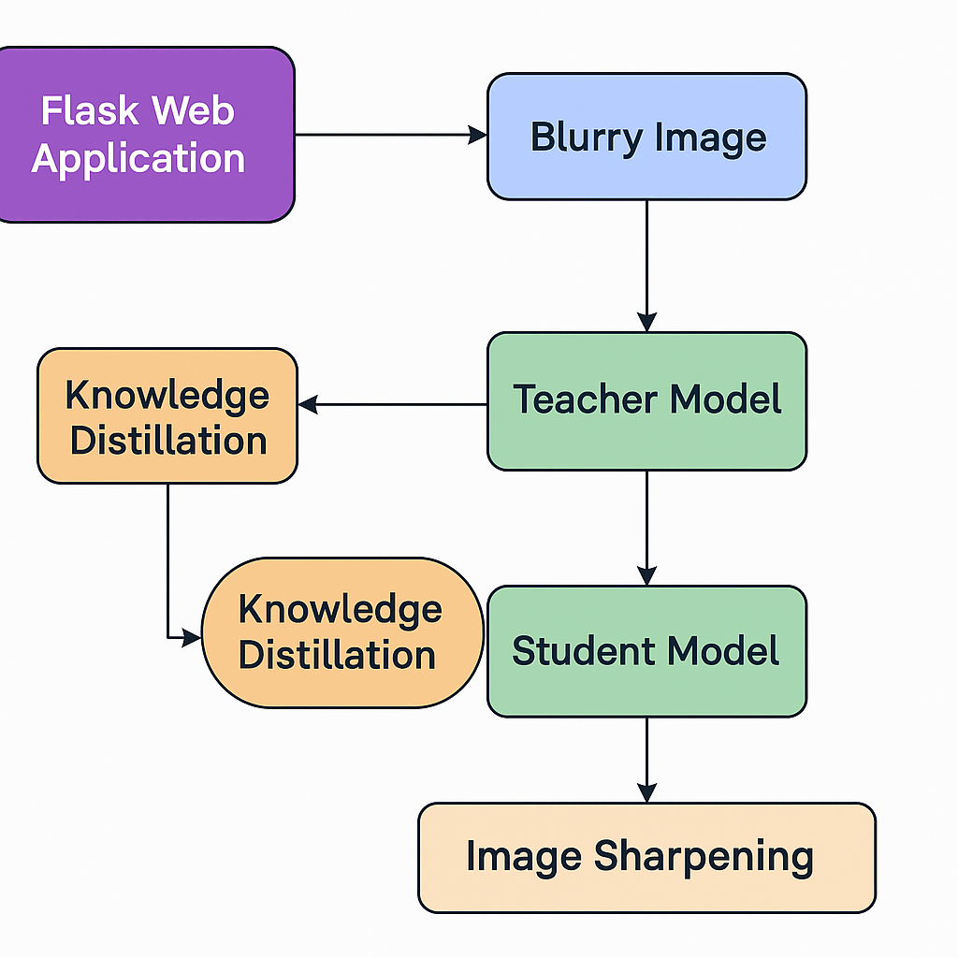

**For Model Trained**

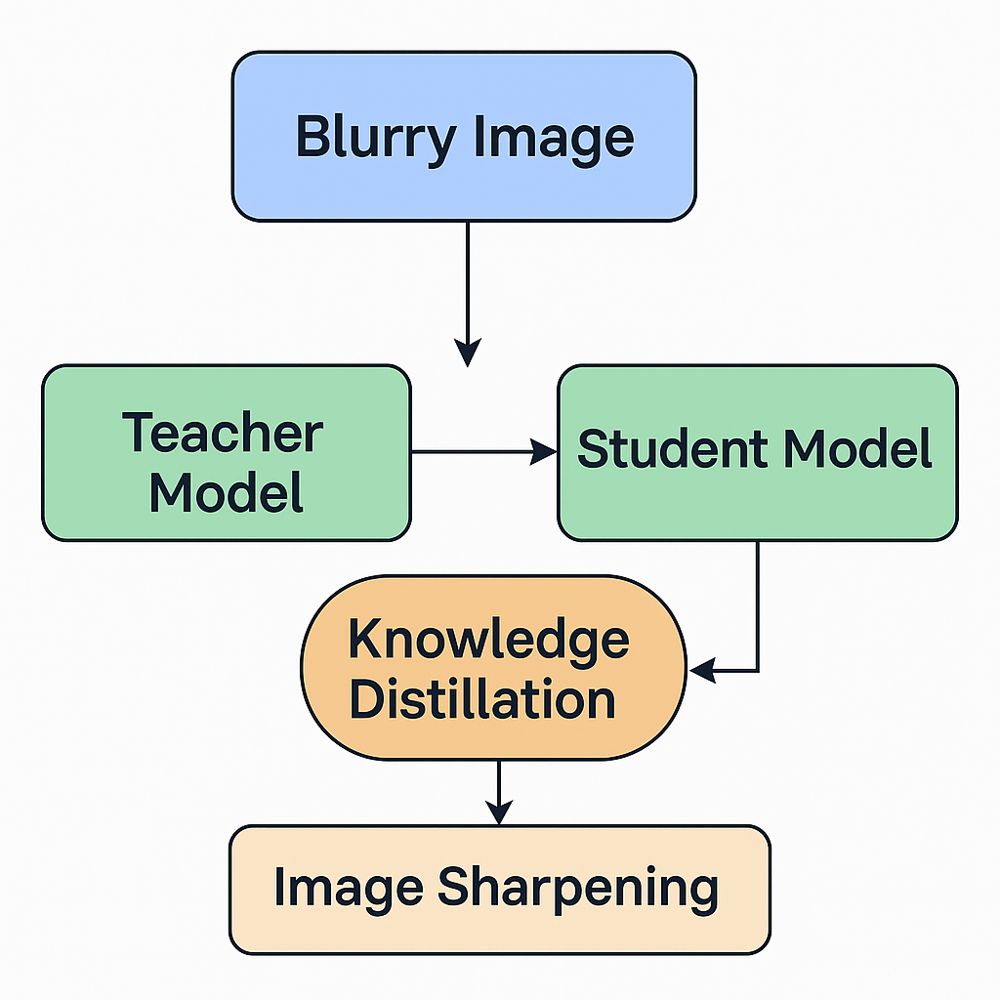

### CHAPTER 8

**RESULTS**

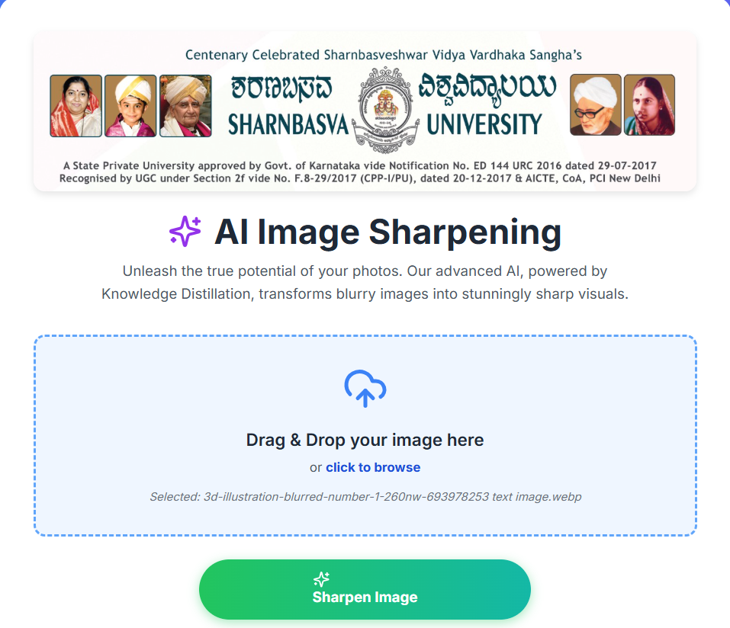

**Figure 8.1 : Output Web Application.**

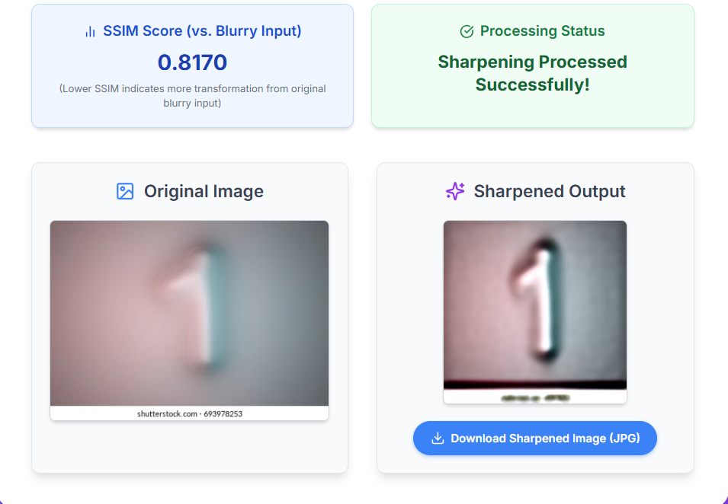

**Figure 8.2 : Predicted Output.**

# CHAPTER 9

**CONCLUSION**

This project successfully demonstrates the effectiveness of using **knowledge distillation** to develop a lightweight, efficient, and accurate image sharpening model. By training a high-capacity **teacher model** to restore sharpness from blurred images and transferring that knowledge to a compact **student model**, we achieve a balance between **performance and efficiency**.



The student model, guided by a combination of reconstruction, perceptual, and distillation losses, delivers high-quality sharpened outputs with significantly fewer parameters and faster inference speeds—making it suitable for **real-time applications** and **deployment on edge devices**.

Additionally, the integration of a **Flask-based web interface** enables users to test the system in a practical, user-friendly way. The model’s ability to enhance image clarity while maintaining high SSIM scores confirms its potential for real-world use cases such as video conferencing, mobile imaging, and surveillance.

In conclusion, the proposed system not only addresses the limitations of traditional sharpening methods and heavy deep learning models but also presents a scalable solution for practical deployment in modern image enhancement tasks.

### REFERENCE

• Intel Unnati Industrial Training. (2025). Image Sharpening using Knowledge Distillation – Training Handbook. Intel Corporation.

• GitHub Repository – Restormer: [*https://github.com/swz30/Restormer*](https://github.com/swz30/Restormer)

• Hinton, G., Vinyals, O., & Dean, J. (2015). *Distilling the Knowledge in a Neural Network*. arXiv preprint [arXiv:1503.02531](https://arxiv.org/abs/1503.02531)

• Zamir, S. W., Arora, A., Khan, S., Hayat, M., Khan, F. S., Yang, M., & Shao, L. (2022). *Restormer: Efficient Transformer for High-Resolution Image Restoration*. Proceedings of the IEEE/CVF Conference on Computer Vision and Pattern Recognition (CVPR), 5728–5739.

• Johnson, J., Alahi, A., & Fei-Fei, L. (2016). *Perceptual Losses for Real-Time Style Transfer and Super-Resolution*. European Conference on Computer Vision (ECCV), 694–711.

• Zhang, K., Zuo, W., Chen, Y., Meng, D., & Zhang, L. (2017). *Beyond a Gaussian Denoiser: Residual Learning of Deep CNN for Image Denoising*. IEEE Transactions on Image Processing, 26(7), 3142–315